1. **PURPOSE:**

To describe the procedure For Operation and calibration of Gas chromatogram.

1. **SCOPE:**

The procedure applicable to the following Gas chromatogram in Quality Control laboratory.

**Make :** Younglin Instrument

**Model :** ACME 6100

**Instrument ID No. :** DIPL/QC/INS/GC/001.

1. **RESPONSIBILITY:**
   1. Analyst-QC is responsible to follow this SOP.
   2. Head-QC/Designee is responsible for ensuring implementation of this SOP.
   3. Head-QA/Designee is responsible for monitoring overall compliance of this SOP.
2. **DEFINITION:**

Nil

1. **PROCEDURE:**
   1. **Operation:**
      1. Fix the appropriate column to the system as per the method.
      2. Check for any leaks occur in the flow line path.
      3. Switch on the main power of the instrument.
      4. Switch on the CPU, monitor and printer.
      5. Press the Power button on front, right lower side of the Gas Chromatograph.
      6. Double click on the Autochro-2000 Software from the desktop.
      7. User login dialog box will appear as shown in the below figure. Enter user name, then Log file recording will start.

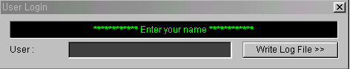

User Login Dialog box for log file recording

* + 1. After LOG Tracer starts, it performs setting COM port as shown in the below figure. Check for communication whether the GC recognizes the COM 1 as ACME 6000GC it gives a beep sound will come then click ok.

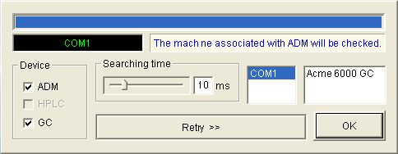

Port Searching Dialog Box

* + 1. After clicking ok, below screen will appear.

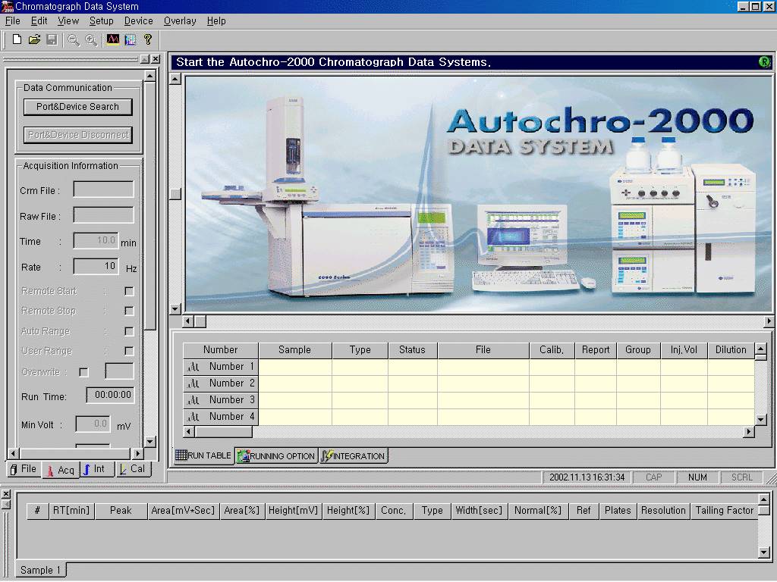

Autochro-2000 Software Screen

* + 1. In the Autochro-2000 Software Screen window, go to setup menu, select GC. Then below screen will appear. Then click ok.

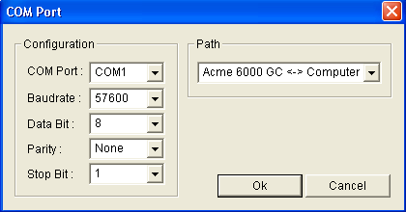

Setting COMPORT

* + 1. The following window will be displayed.

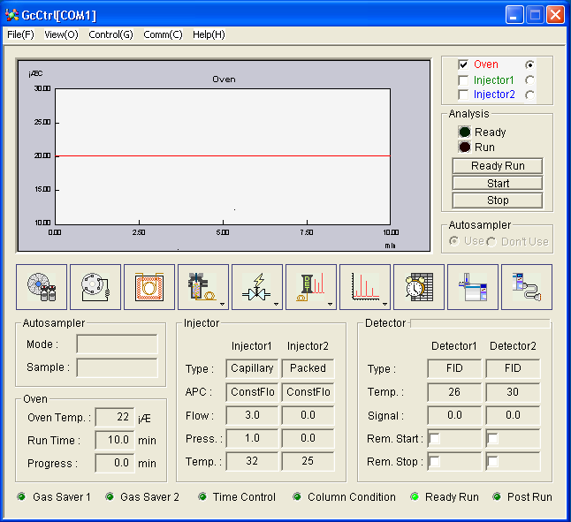

Main Window

* + 1. Press APC Button  and Enter the column details like description, Dimensions etc., as mentioned below…

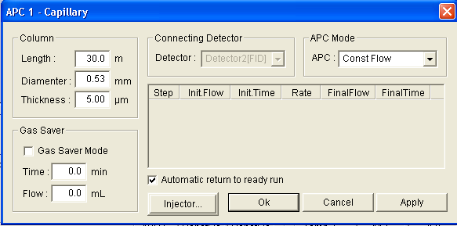

* + 1. In the above screen, select the Injector button, set the column flow rate and also set the injector temperature as per the method.
    2. Select the Oven button  and set the required temperature as per the Method.
    3. In the above screen, select the Injector button , set the column flow rate and also set the injector temperature as per the method.
    4. Select the Oven button  and set the required temperature as per the Method.
    5. Select the Detector button , set the temperature, Electrometer ON, Auto Ignition ON, gas flows as Air 300 – 400 ml/min, Hydrogen 30 –40ml/min and makeup gas 20 – 30ml/min(or as per the method) set the offset value to the above 5,Init Ignition Air flow should be above 100–300 ml/min.
    6. Click on File menu from main window and select save the method.
    7. After acquiring the set values, Ready will appear on the main window and on GC Key pad.
    8. In the Autochro-2000 Software Screen, Select file menu then new, the following screen will be displayed

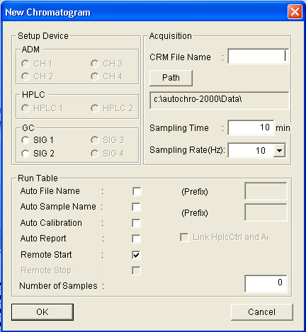

  New Chromatogram Dialog Box

* + 1. In the above window, enter the CRM file, create the data path, select the signal, sampling time, sampling rate, select the auto filename with prefix, auto sample name with prefix and no of samples then click ok.
    2. After getting Ready, Inject the samples and press START button on the main window or on the GC Keypad.
    3. Enter the sample details in Run Table on Chromatogram Window of Auto Chrome 2000 Software screen.

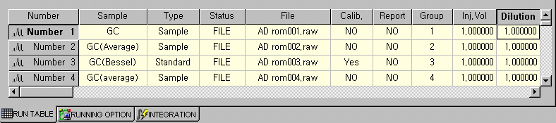

Run Table Sheet

* + 1. After completion of a chromatogram run, go to integration on chromatogram window. Select the relevant integration parameter and apply to the chromatogram.

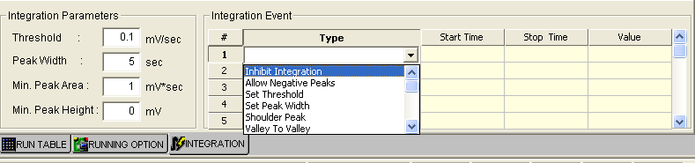

* + 1. Press Int. button from workspace window.



* + 1. To view the results on Integration Results Window, press Immediate on Work Space Window

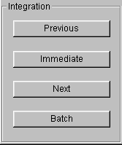



* + 1. Select Cal from Work Space window and select print button to get the Printout

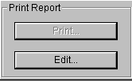

* 1. **Calibration :**
     1. **Calibration Schedule:** Every 4 months.
     2. **SYSTEM PRECISION and DETECTOR SENSITIVITY:**
        1. **Chromatographic Conditions:**

Column : DB-624, 0.53mm x 30m, 3.0µm

Injection Temperature : 280°C

Detector Temperature : 300°C

Pressure : 5.0

Split Ratio : 1:10

Injection Volume : 1.0 µL

Runtime : 15.00 minutes

Oven Temperature : Kept the temperature 180°C for 15 minutes.

* + - 1. **Preparation of Standard Solution:**

Prepare 100 mg/µl solution of each n-Dodecane, n-Tetradecane and n- Hexadecane in n-Heptane.

**Preparation:** Weigh accurately about 50.0 mg of each n-Dodecane, n-Tetradecane and n-Hexadecane in n-Heptane in 50ml Volumetric flask and makeup to volume with n-Heptane. Take 1.0 ml of this solution, make to the volume of 10 ml with n-Heptane.

* + - 1. **Acceptance Criteria:**

1. The RSD of area counts for each n-Dodecane, n-Tetradecane,n-Hexadecane is not more than 15.0
2. The RSD of Retention times for each n-Dodecane, n-Tetradecane, n-Hexadecane is not more than 5.0
   * 1. **FID Sensitivity should be > 10 x 10 -3 c/g**

FID Sensitivity = Average Area of n-hexadecane x 10-6 x 1000

W

* + 1. **Detector Linearity:**
       1. FID-A

Column : DB-624 (0.53 ID, 30 M length, 3.0 µ film thickness

Oven Temp : 100°C (Isothermal)

Injector temp : 180°C

Detector temp : 260°C

Flow rate : 5 ml/ min

Injection volume : 2.0µL

Run Time : 5 min

Spilt Ration : 10:1

* + - 1. **1.0% solution of Benzene and Toluene (Solution–S):**

Pipette out 1.0 ml of Benzene and 1.0 ml of toluene in to a 100 ml volumetric flask make up to the mark with Methanol.

* + - 1. **Sample Solution (Solution-TS):**

Pipette out 2.0 ml of Solution-S in to a100 ml volumetric flask. Make up to the mark with Methanol

* + - 1. **Solution-1(50ppm):**

Pipette out 0.5 ml solution-S, into a100 ml volumetric flask. Make up to the mark with methanol.

* + - 1. **Solution-2(100ppm)**:

Pipette out 1.0 ml solution-S, into a100ml volumetric flask. Make up to the mark with methanol

* + - 1. **Solution-3 (150ppm):**

Pipette out 1.5 ml solution-S, into a100ml volumetric flask. Make up to the mark with methanol

* + - 1. **Solution-4 (200ppm):**

Pipette out 2.0 ml solution-S, into a100ml volumetric flask. Make up to the mark with methanol**.**

* + - 1. **Solution-5(300ppm):**
      2. ipette out 3.0 ml solution-S, into a100ml volumetric flask. Make up to the mark with methanol.
      3. Procedure: Inject 2.0µl of solution-1, 2, 3, 4, and 5 for FID-A Separately. Calculate the peak area ratios between Benzene, Toluene Separately. Calculation coefficient correlation for benzene and Toluene.
      4. **Result**: The response of the detector should be linear for above concentrations. The coefficient of correlation should not be less than 0.99.
    1. **Oven temperature calibration:**

Set the column oven temperature at 40°C, 100°C, 150°C, 200°C and 280°C respectively and measure the temperature attained at each setting by placing the temperature probe inside the column compartment.

**Acceptance criterion:** The temperature attained inside the column compartment should be within ±2°C for 40°C and ±5°C for 40°C, 100°C, 150°C, 200°C and 280°C to the set temperature.

1. **Formats / annexure(S):**
   1. Instrument Usage log Book : QC048-FM088
   2. GC Calibration Record : QC017-FM053
2. **CHANGE HISTORY:**

| **Revision No.** | **Effective Date** | **Details of Revision** | **Ref CCF No.** |
| --- | --- | --- | --- |
| 00 | 01/06/2007 | New SOP introduced across all the API manufacturing facilities of Discovery. | -- |
| 01 | 01/08/2009 | Formats given clear and clarity | -- |
| 02 | 01/03/2014 | 1. Incorporate GC Column Oven Calibration procedure. 2. Calibration Frequency Change 3 months to 4 months. 3. Formats are the part of SOP. So prepared separately. | -- |
| 03 | 01/09/2016 | 1. Calibration format are prepared in one format. 2. Calibration procedure is changed to cover the maximum operation temperature for GC detector upto 300°C. | -- |
| 04 | 01.01.2017 | 1. SOP format changed make to in line with SOP-QA-001-04. 2. Injector linearity procedure was removed due to it is not auto injector. 3. Detector linearity procedure was introduced. | QC-CRF-025/16 |